2016 Dec 1st GE Lagos Garage Report

The program in numbers:
- 4 weeks from payment receipt to first day of class
- 1600 applicants from application form on Facebook
- 50 applicants invited for live selection event
- 25 final program participants selected by the judging panel
- 4 weeks of classes
- 1 opening ceremony
- 3 engineers delivering coursework
- 4 outside experts delivering lectures
- 50 investors visited the space
- Dozens of GE customers visited the space on tours with GE representatives
- 15 program participants active at the end
- 2 fundable businesses from the first program
- 1000 + social media followers gained across Facebook, Instagram and Twitter (before accounts were deleted)

The first education program of the 2016 GE Lagos Garage started on November 14 with 25 participants. The program closed on Dec 9 after 20 days of instruction or events. The space was
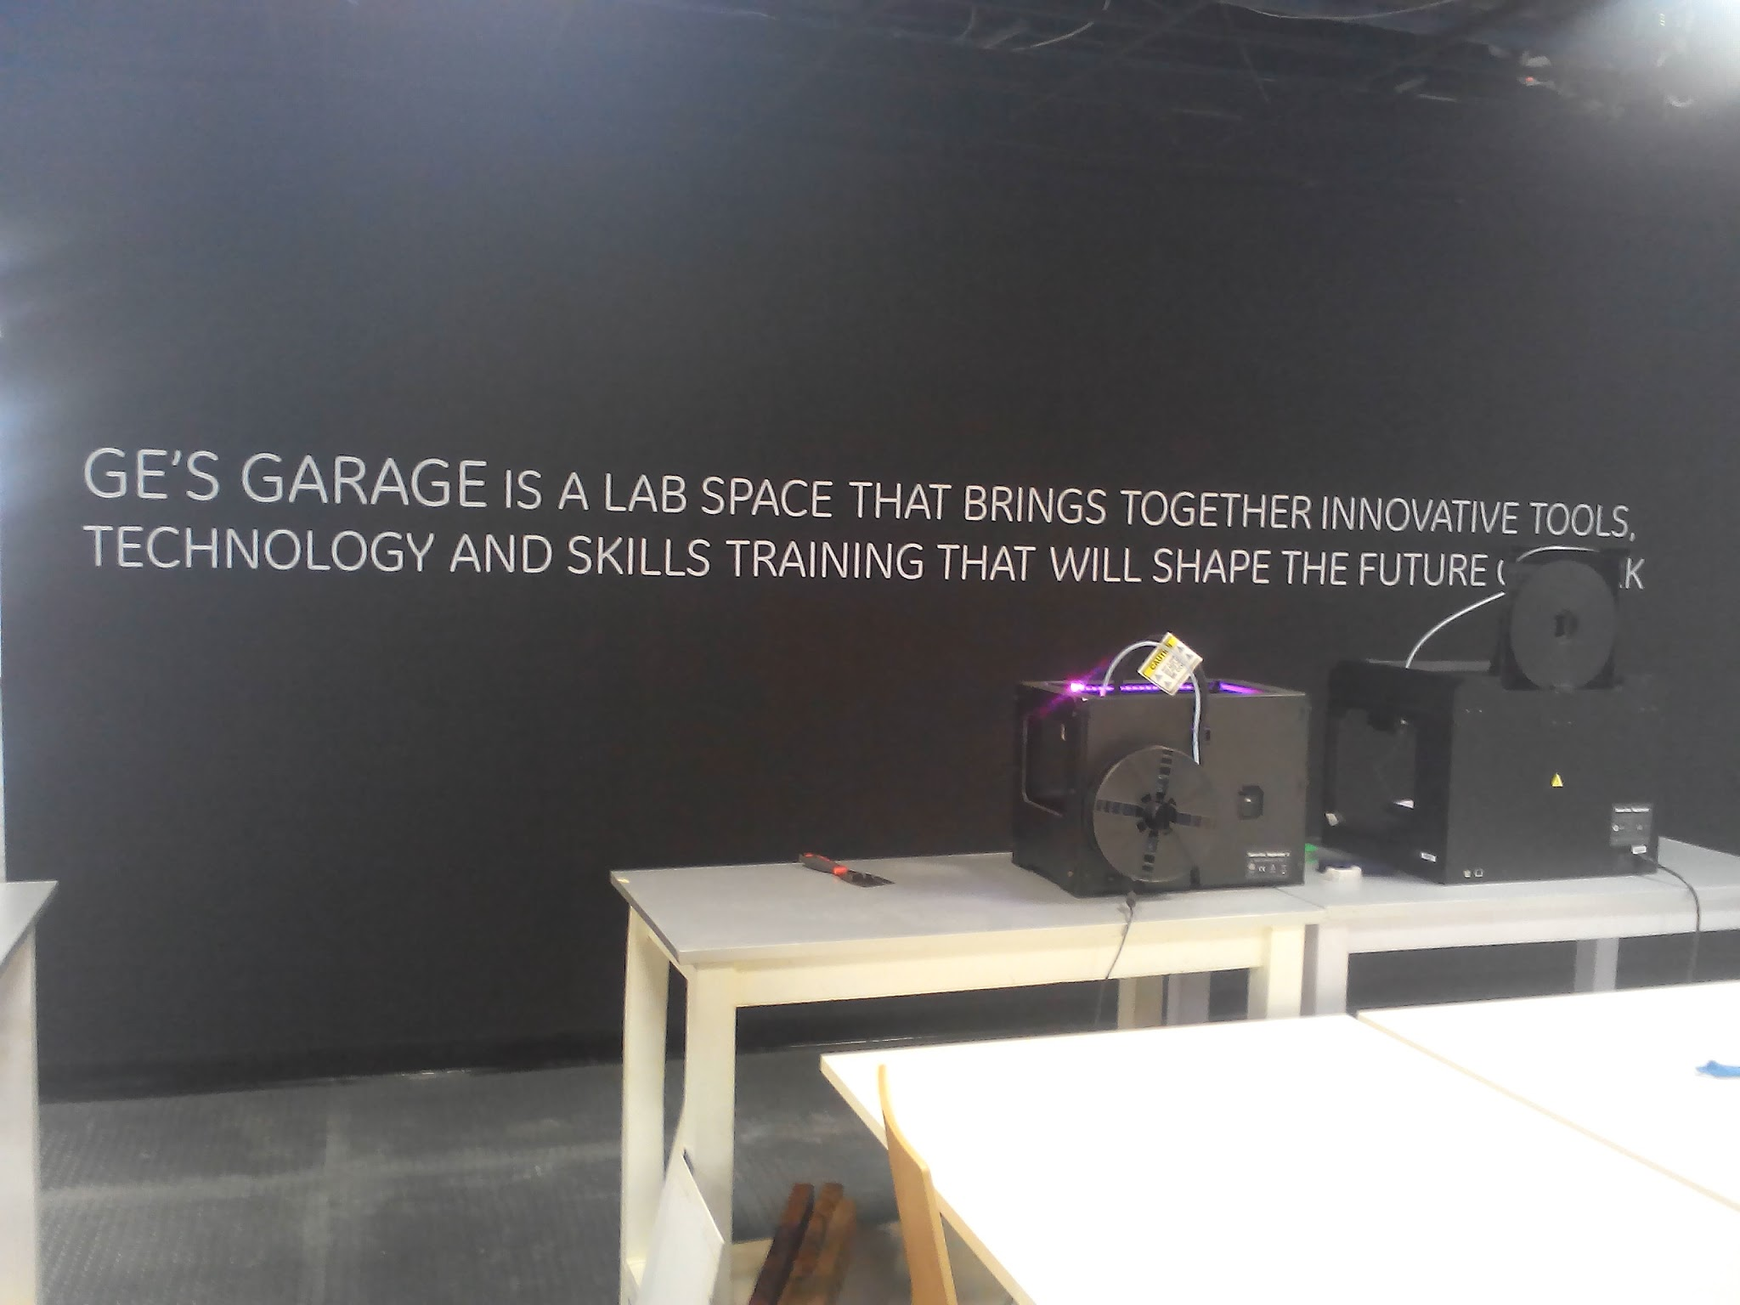
open and staffed every week day and NeuBridges staff were often there on the weekends as well.
Entrance of the GE Lagos Garage

Training
Training was delivered by 3 instructors, Chika, Dapo, and Ugo who were also instructors from the original training program in 2014. Program Manager, Rich Tanksley also was on site for every day of the education program and worked with the program participants on their business ideas individually and delivered several lectures.

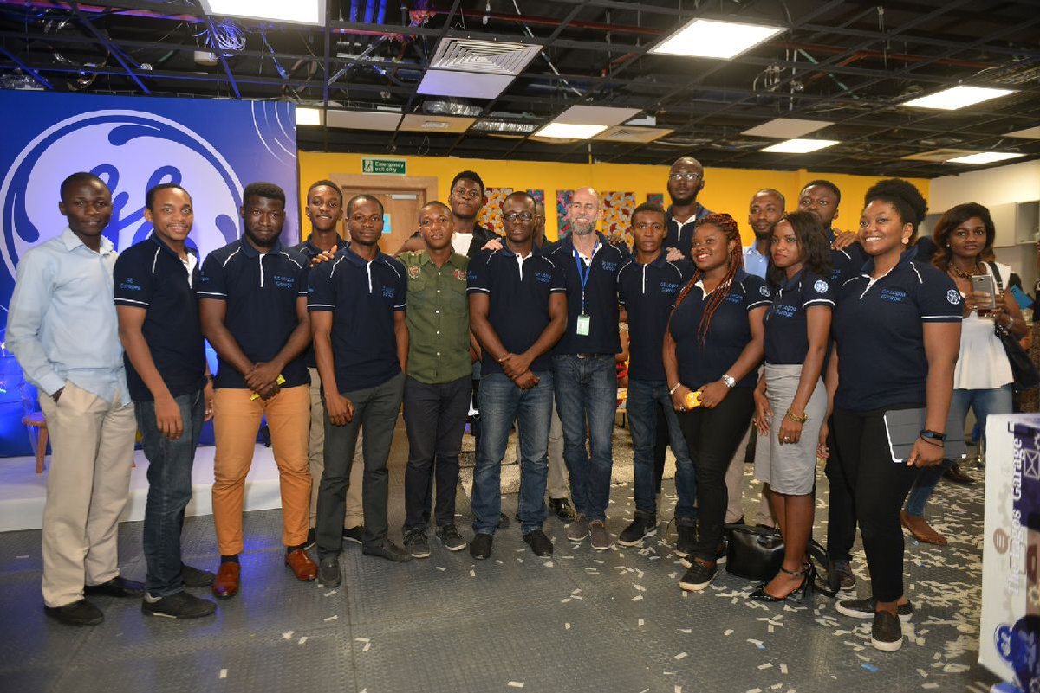
GE Lagos Garage participants 2016 and Richard Tanksley Program Manager

The class was sharply divided in their skill sets in 3D design and printing. Some participants were experts while some had never seen a 3D printer before. Because of this, advanced manufacturing technique training was delivered on a more individual basis by the instructors to the participants based on their skill levels. The business and entrepreneurship training was delivered on a more structured basis to all participants.

Four guest lecturers and Rich Tanksley delivered supplemental lectures to the participants. They were:
- Chris Quintero, hardware design expert and investor from Bolt.io
  - Hardware design and business principles for entrepreneurs
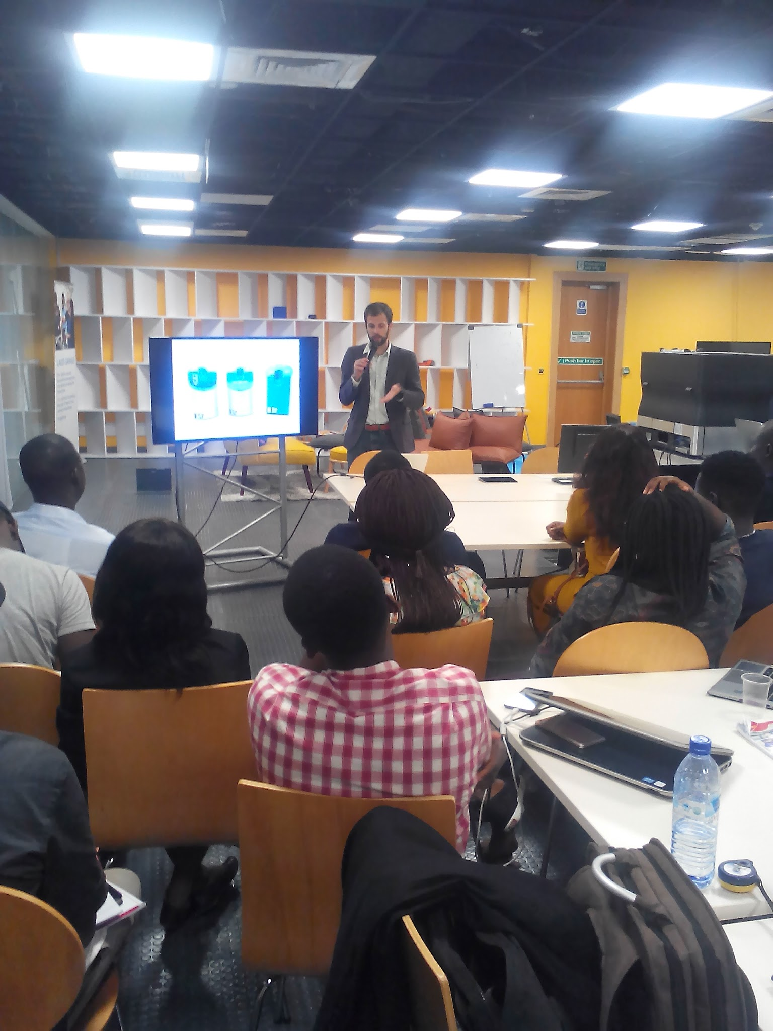
Chris Quintero conducting his lecture

- Lexi Novitske, Lead Investor from Singularity Investments
  - How to pitch your company to investors
- Nifemi Marcus-Bello, Lead Industrial Designer, Tecno
  - Hardware design
- Dola Posh, professional photographer
  - Principles of product photography
- Rich Tanksley, entrepreneurship professor and Program Manager
  - How to be a high performer
  - Business model canvas
  - Sales techniques and tactics
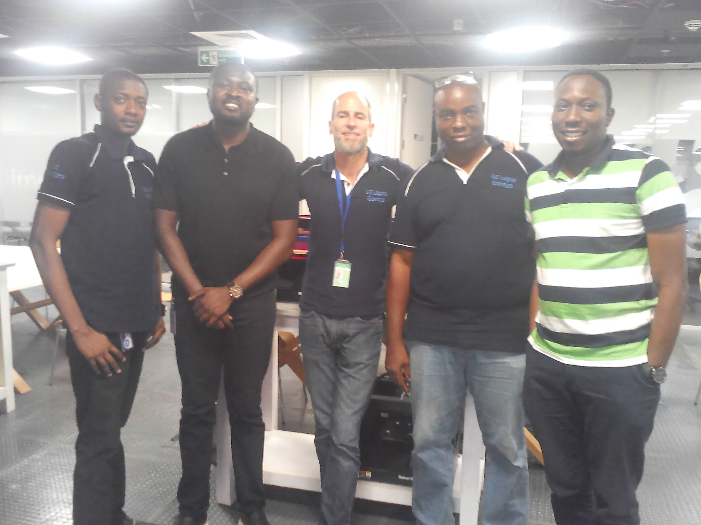
NeuBridges Team and Nifemi Marcus-Bello, Lead Industrial Designer, Tecno

Successes
One participant who is 3D printing replacement auto parts pitched his business idea to investors and will likely get it funded soon
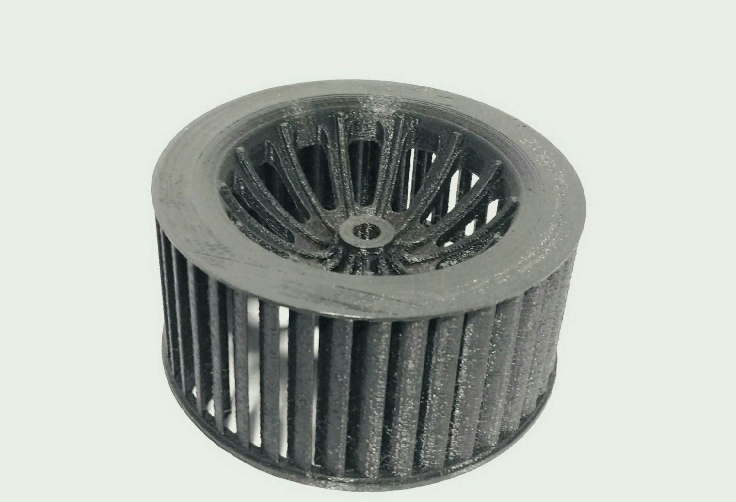
A functioning AC blower for a Mercedes that was printed by a participant

Almost all participants got to a point where they had a working prototype that could be used to build a business around.

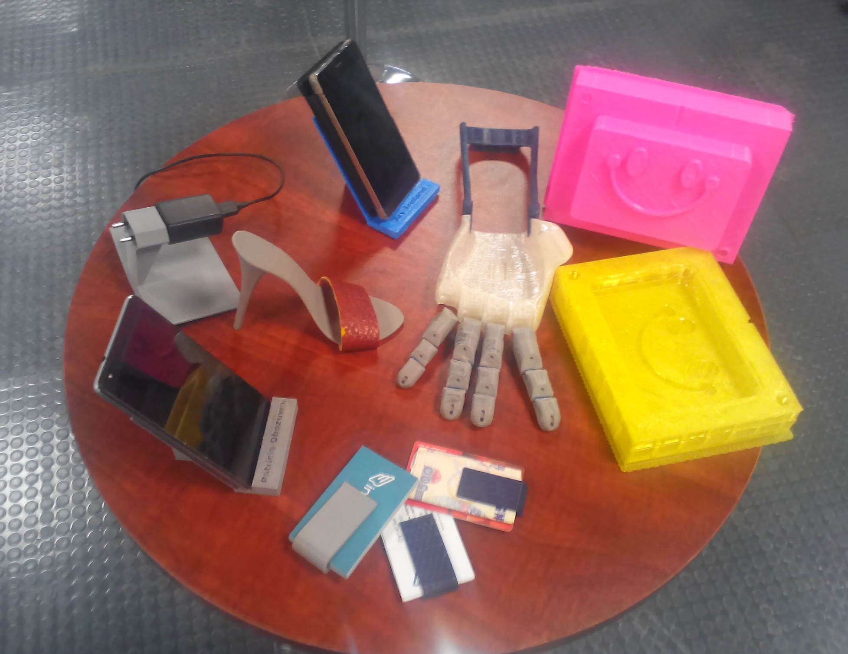
Some of the prototypes that were produced

Attrition
There was about a 40% drop-out rate among the participants. After inquiries with the participants we discovered several reasons for this:
- Several participants didn’t come at all because they were unable to find affordable housing in Lagos for the program
- Two participants left for NYSC training
- 1 participant got called to another city for work
- Several participants were unable to get to and from the program so stopped coming

The remaining drop-outs most likely dropped out because they didn’t understand the nature of the program or thought that they were going to get funding to start their business.

Possible remedies we will try to the next program:
- Better communicate the nature of the program and the fact that they will not get funding for their business ideas from GE. (We need to get the social media pages back up to do this)
- Make it clear before people apply that they have to provide their own transportation and housing

Site visits
The launch event was a huge production with at least 100 guests including many top GE executives.
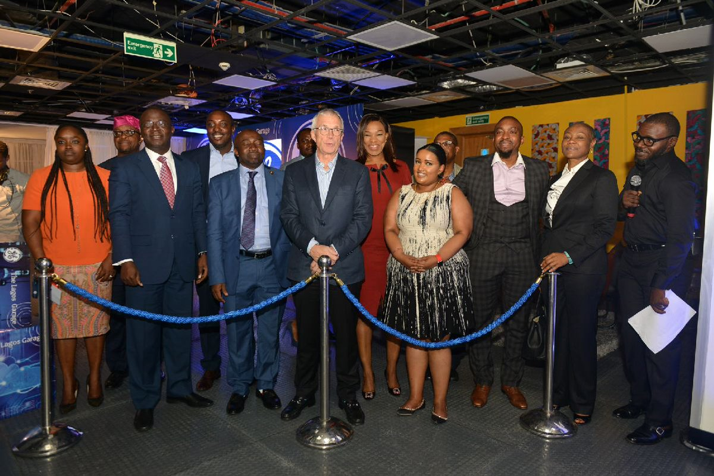

GE Staff members come through the Garage on a daily basis. One tested laser etching of award plaques for GE. There were many visits by GE sales people / personales with clients. All were greeted by NeuBridges staff and given a tour of the space.

The garage hosted 50 investors from Silicon Valley on the Tour of Tech. The investors got a tour of the space and were shown how 3D printing works. They interacted with the program participants and heard about their business models.

Amplification
Because of GE’s deal with Pulse, all events at the Garage were amplified on Pulse. They also covered all events and produced videos from them. All content was put up on Pulse at http://pulse.ng/feat/ge/ and amplified on social media.

A google search of “ge lagos garage” returns 23,000 results.

Moving Forward
The next education program and the first industrial training session are planned for February. Curriculum will be adjusted based on the feedback from the first session. We are planning on splitting the curriculum into two tracks based on the skill level of the participants.

We plan on adjusting the time of the program. Feedback from participants was that ending at 9pm was too late for them to get home safely. Most likely we will have it end at 7pm.

Currently the Garage has no social media presence. The plan is to work with Yewande to align the social media pages with GE guidelines and create them again. This needs to be done soon, as Facebook was where we gathered applications for the program.

